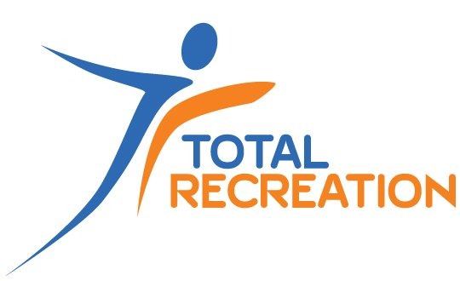

Member Handbook

For National Disability Insurance Scheme Participants

June 2022

Welcome
Welcome to Total Recreation.

This document is a Handbook for people who are members of Total Recreation and are also a National Disability Insurance Scheme (NDIS) participants.

About Total Recreation
Total Recreation is an organisation that has a focus on sports, leisure and programs for people with a disability. Total Recreation is located in Darwin and Alice Springs in the Northern Territory.

Our services include NDIS supports also known as the National Disability Insurance Scheme.

Our Service Charter (a document about our organisation) can be given to you at the start of our services.

About the National Disability Insurance Scheme
The NDIS is a new government program to help people under 65 years who have a forever, big disability. It also helps children under six years who need extra help.

The NDIS hopes to help you build skills, do things in your home and get out in your community. The NDIS is based on the idea that everyone with a disability is different and needs different things, so there is a choice.

Total Recreation is a registered NDIS service provider. This means we have been through checks to make sure we have good services. When Total Recreation gives you a NDIS service, these are the things we think are important:
Your interests, likes, culture and needs
Your privacy
Your choices

Being included in your community
Your strengths
Your rights
Keep you safe
Do good services

Your rights when receiving supports
Rights are things you are supposed to have. Within our services you have the right to (these rights also apply to guardians, carers, and family members too):
 | Be treated fairly, with respect and dignity.
 | Take part as a valuable member of the community, feel included and enjoy your sport, leisure and program activities.
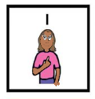 | Make choices about your recreation, sport and leisure activities.
 | Be free of harm, neglect, abuse, exploitation and violence.
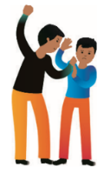 | Know what your rights are.
 | Access your information (or your legal guardian or carer if you say to us).
 | Have your information kept safe and private.
 | Say no to a service, make a complaint or give feedback.
 | Tell us what training you think your employee needs.

Your responsibilities when receiving supports
Responsibilities are things we would like you to do when taking part in a Total Recreation service. Your responsibilities are (these responsibilities apply to guardians, carers, and family members too):

Telling Total Recreation if you can't make it to the activity or appointment you are booked in for – you should always give at least two days’ notice where possible.
Telling Total Recreation about the supports that you want, and how you want to receive them.

Being respectful to our employees, volunteers, members and any equipment used.

Use nice language, do not harass others and do not hurt others*.
Following the direction of Total Recreation employees and volunteers while doing an activity as well as the rules of sports and programs.
Telling Total Recreation if you have any problems
Letting Total Recreation know if you want to end services, if your NDIS Plan changes or if you stop using the NDIS.

*If a member acts in a way that is aggressive, harms others, harasses others, is discrimination or exploitation, we may work with you to find out why these behaviours are happening and if we need to make changes to our environment. If they are big problems, we may support you to access a behaviour support worker. If changes can’t be made, we may have to stop Total Recreation services for a while for the safety of others.

Complaints
 | A complaint is something you are unhappy about. Like the way a service or person treated you, handled your information or did / did not do when giving you a service.
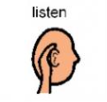 | We are always open to hearing your feedback so if you are unhappy with us please have a chat with your employee.  Or you can also write to us, phone or email your complaint to:  keoh.goodall@totalrecreation.org.au OR PO Box 40112 Casuarina NT 0811
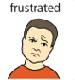 | If you are not happy with the way we dealt with your complaint, or want help, you can contact the: Health and Community Complaints Commission on (08) 8999 1969
You can also talk to the NDIS Quality and Safeguards Commission if you feel services weren’t safe or good on
1800 035 544

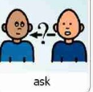 | You can get help with complaints from ‘advocacy’ mobs. Search for one here: https://disabilityadvocacyfinder.dss.gov.au/disability/ndap/

Abuse and neglect
Abuse is when someone tries to take away your rights. Abuse is when someone does things to you that make you upset or frightened. Abuse is wrong.

Total Recreation does not tolerate any abuse or neglect and works to keep you safe. If you think you are being abused tell someone you trust as soon as you can.

There are different kinds of abuse.

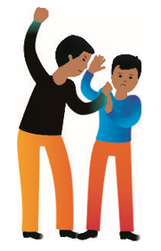 | Physical abuse  When someone hurts your body, such as hitting or restraining you.
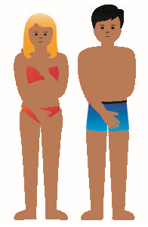 | Sexual abuse  When someone makes you do or watch sexual things that you don’t want to do. This can include the grooming of young people and children.
Financial abuse

When someone spends your money or takes your belongings without asking or encourages you to buy them things.
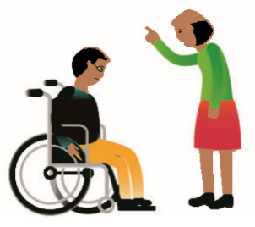 | Emotional abuse  When someone does things to hurt your feelings.
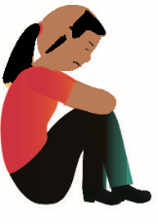 | Neglect  When your care and support is not enough to meet your basic needs.

Other things to tell you
Here are some other important things we would like to tell you about Total Recreation and its NDIS services.

Code of Conduct
Total Recreation has what is called an ‘Code of Conduct’.

This tells our employees that they should behave in a good way with you, your guardian, family and carer.

You are welcome to ask for a copy of this or make a complaint if you feel we haven’t acted in a good way.

Feedback
Total Recreation likes hearing from you about how well our employees provide you with supports. We will give opportunities for members, family, carers and advocates to tell us about where we can improve our services and the type of training you think our employees need.

Restrictive practices
Occasionally, some people with a disability may hurt themselves or others. Total Recreation wants to keep everyone safe. If this happens, we will try to find out why the behaviour happens and work together to help.

If this doesn’t work, we may need to refer you to another service who better meets your needs. We will make sure you are safe and supported until this happens. This is because our employees are not trained in using what is called ‘restrictive practices.’ Restrictive practise are something someone does very carefully to stop you from moving or hurting yourself for a short time to keep you and other people safe.

Very rarely and in an emergency, we might use restrictive practices to save a person’s life or to stop bad harm. If this happens, we will use the smallest action we can. After this happens, we will look at why we had to do this.

We also need to let the government know it happened. We will ask if it’s okay to do this and let you know what they say face-to-face and by letter.

We will let you and your carer / family and / or guardian know the restrictive practice happened. You can also ask us for a review of what happened or make a complaint.

Incidents
An incident is something that might, or has, hurt someone. It can include slips, trips, a car accident, burns and someone hurting another person.

If an incident happens and involves you, Total Recreation employees must tell their Manager who will complete a form.

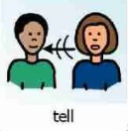
You can tell any Total Recreation employee member if you see an incident. If an incident happens, we will have a look at why it happened to stop it occurring again.

If an incident involved you, we will tell you what we found when we looked at it by face-to-face and by letter.

Very serious incidents are like where someone gets hurt. We also need to let the government know this happened (NDIS Quality and Safeguards Commission). We will ask if it’s okay to do this and let you know what they say face-to-face and by letter.

Medication
Total Recreation does not administer medication to its members.

Adapted from Tipping Foundation at https://www.tipping.org.au/about-us/zero-tolerance-to-abuse/

